The KSMGC News **November-December 2023**

Knollwood Senior Men’s

EVENTS CALENDAR

***Wed, Jan. 3 Knollwood LN/LG/Skins Jim McCormick***

***Mon, Jan 8 Knollwood Board/Membership Mtg at 1pm***

***Wed, Jan 10 Knollwood 2-Man Scramble Mike Rieken***

***Wed, Jan 17 Santa Anita LN/LG/Skins Steve Skinner***

***Wed, Jan 24 Knollwood LN/LG/Skins Andy Halani***

***Wed, Jan 31 Knollwood LN/LG/Skins Bruce Pearson***

***Mon, Feb 5 Knollwood Board/Membership Mtg at 1pm***

***Wed, Feb 7 Knollwood Partner Better Ball Neil Beckenstein***

***Wed, Feb 14 Knollwood LN/LG/Skins Larry Tash***

***Wed, Feb 21 Olivas Links LN/LG/Skins Steve Burhans***

***Wed, Feb 28 Knollwood LN/LG/Skins Tom Oatway***

***Mon, Mar 4 Knollwood Board/Membership Mtg at 1pm***

***Wed, Mar 6 Knollwood 2-Man Scramble Rob Lindeen***

***Wed, Mar 13 Knollwood LN/LG/Skins (Needs Chairman)***

***MEMBERSHIP-*** *Mike Rieken.* **Our membership total is 118. The new member bios will be included in the website as soon as available. If a member recruits a new member, he will be awarded a free play voucher at Knollwood CC. Some members allow their vouchers to be given to the new member as an incentive to signing up. It costs $80 for a new member to join; a free voucher cuts that cost essentially in half. With the free lunches provided during the year, membership is actually a freebie.**

***2024 TOURNAMENT SCHEDULE- The 2024 event schedule is posted on the website. We will need a volunteer to chair the March 13 LN tournament at Knollwood. If you are a new chairman, and need training, it is available. To volunteer, call Norris Clark or Andy Halani. The current schedule is attached:***



Golf Club – Est. 1983

[www.ksmgcgolf.com](http://www.ksmgcgolf.com)

[ksmgcgolf@gmail.com](mailto:ksmgcgolf@gmail.com)

Board of Directors

President (2024)

***Norris Clark***

***818-472-9382***

1st VP - Tournament Chm.

***Andy Halani (2024)***

***818-800-2632***

2nd VP - Handicap Chm.

***Vacant-Need Volunteer***

Secretary- (2024)

***Dick Bratkovich***

***818-886-4514***

Treasurer – (2024)

***Gordon Seaberg***

***323-822-1971***

Away Tournament Chm. (2024)

***John Nyugen***

***818-261-4982***

Rules Chairman***: Vacant***

Membership Chairman

***Mike Rieken***

***818-399-9510***

Webmaster (2024)

***Bill Brocklebank***

***805-509-2222***

Scoring Chairmen:

***Mike McGann***

***818-317-9042***

***Steve Burhans***

***661-877-2608***

***Neil Beckenstein***

***818-360-4858***

Newsletter Chairman

***Tom Oatway***

***661-263-9778***

Photographer

***(Needed)***

Interclub Chairman

***Jim Greer***

***818-999-1220***

Past President

***Allison Fields***

***818-281-8838***

Founding President

***Martin Bennyworth***

*Knollwood Country Club*

*12040 Balboa Blvd.*

*Granada Hills, CA 91344*

818-363-8161

***Page 2***

***TOURNAMENT ENTRY FORMS- The entry forms for January and February 2024 are attached below, and are also available on the KSMGC website. Please note that your entry for a home tournament is due to the chairman 9 days prior to the event, and entry forms for away tournaments are due 14 days prior.***



***BOARD OF DIRECTORS OPEN POSITIONS- We have several openings in key positions on the KSMGC Board. One is the Rules Chairman. One does not need to memorize the Rules of Golf in this job. It requires fielding member questions, and a willingness to pull out your Rule book and search for an answer. The Rules Chairman will chair the Competition Committee where Local Rules are discussed and updated as necessary. If players have a question on Rules when they turn in their scorecard, a decision will be required prior to the Scorer tabulating the results.***

***Another key position that needs a volunteer is the Handicap Chairman. He will have access to the SCGA GHIN system and will periodically publish the current Handicap Index for Board members and Tournament Chairmen. Chairmen will need player handicaps to establish pairings for Tee Times.***

***HOLE-IN-ONE Challenge for 2024: Members are invited to enter a Hole-In-One competition. This was competed in 2023, and no hole-in-one was made in a KSMGC tournament. The fund has doubled for 2024 since there was no winner in 2023 and the funding rolls over. It costs members $10 to enter for 2024, and the entry form is on the website. Make your check to KSMGC and send it to Mike Rieken, who is managing the competition. KSMGC also offers a $100 payout for any hole-in-one made in a KSMGC tournament. Maybe you can be a lucky winner.***

***Knollwood Senior Men’s Golf Club Hole-in-One Pool. Run by Mike Rieken. This is a Voluntary Program***

***1. Cost - $10 a year. Pay cash or check to Mike Rieken —100% pay-back to winner. Check paid to Mike Rieken, not KSMGC.***

***2. Runs January 1st through December 31st. Renewable each calendar year. If no winner, pool money carries over to the following year.***

***3. Enter any time during the year. Must be entered in the pool at the time that a hole-in-one is made in order to qualify for payout.***

***4. Payout at the end of the year. Payout divided if more than one winner.***

***5. A record of who is in the pool, and the total dollar amount, will be displayed on our website, ksmgcgolf.com, under Tournaments/Hole-in-one Pool.***

***6. On December 31st, Mike Rieken will give KSMGC treasurer the total monies collected with a spread sheet.***

***7. All sanctioned KSMGC tournaments, both home and away, qualify for the payout. This pool is in addition to the $100 paid by the Club.***

***Any questions, Contact Mike Rieken 818-399-9510 or email at mwr7593@aol.com***

***SENIOR CUP- Starts January 3, 2024. On the first tournament of the new year, members will again begin to be awarded Senior Cup Points to qualify for the year-end playoffs in Nov. 2024. For each low net win in a flight, the member receives 3 points. Second place winners get 2 points; one point goes to 3rd place. An additional point is awarded for simply entering a LN tournament. Twenty-four players will qualify to play in a 2-day Senior Cup Match Play Tournament.***

***TOURNAMENT HIGHLIGHS-***

***Nov. 1 – Low Net, Low Gross, and Skins @ Knollwood. Norris Clark chaired this tournament. Complete results are shown on the KSMGC website.***

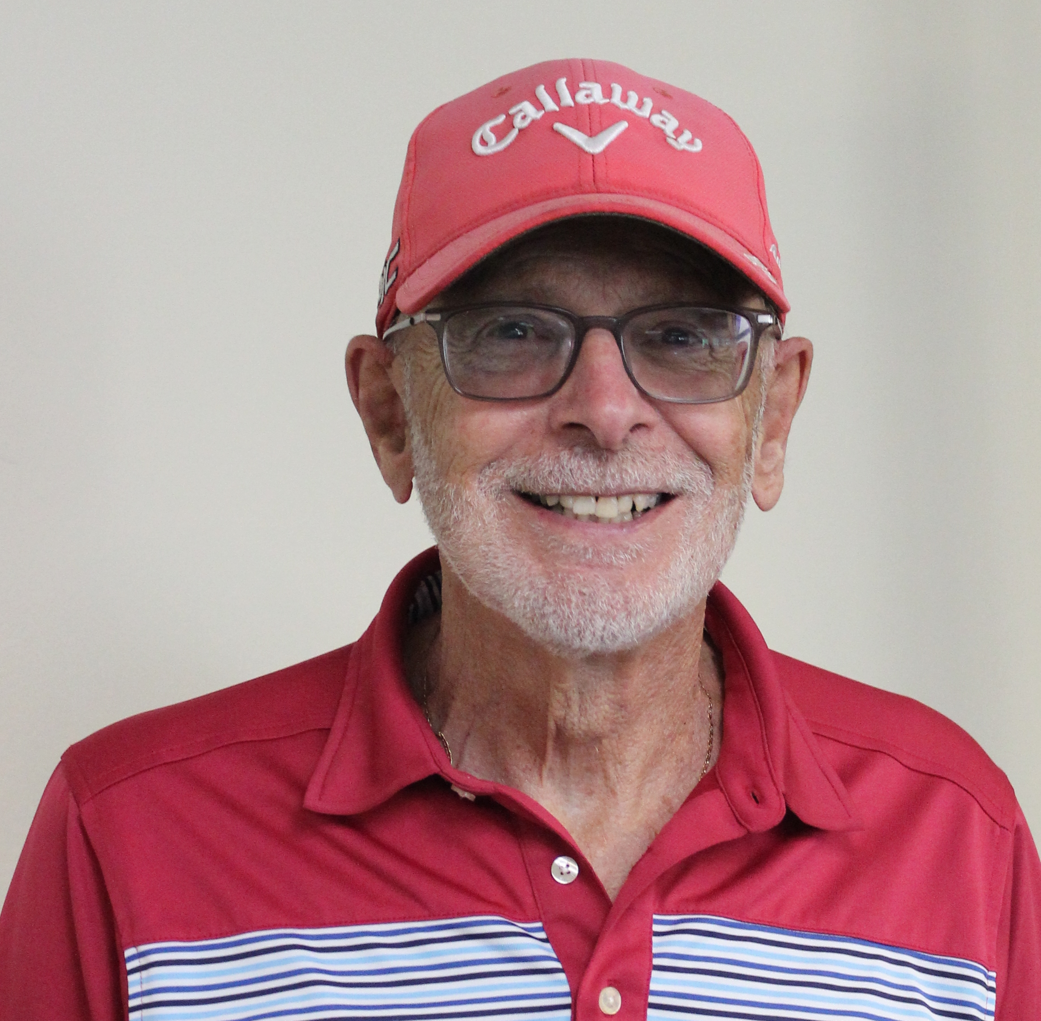

***Flt A LN- Willie Jenkins 89/net72***

***Flt B LN- Chris Cho 96/net75***

***Flt C LN- Dan Sniegowski 98/net71***

***Flt A Skins- Beckenstein (2); Manjikian, Sowa, Skinner, Kim, and Nguyen (one each)***

***Flt B Skins- Cho (2); Yochim, Chapin, Gouzy, Savilla, Hamilton, and Brocklebank (one each)***

***Flt C Skins- Goldstein (2); Clark, Lindeen, and Sniegowski (one each)***

***Low Gross Flt A- John Nguyen; LG Flt B- Herman Gouzy***

***CTP- Beckenstein, Hong, Rieken, Riley, Hamilton, and Cho (one each)***

***Pool- Gouzy and Manjikian***

***Nov. 8 – Low Net, Low Gross, and Skins @ Knollwood. Steve Skinner chaired this event.***

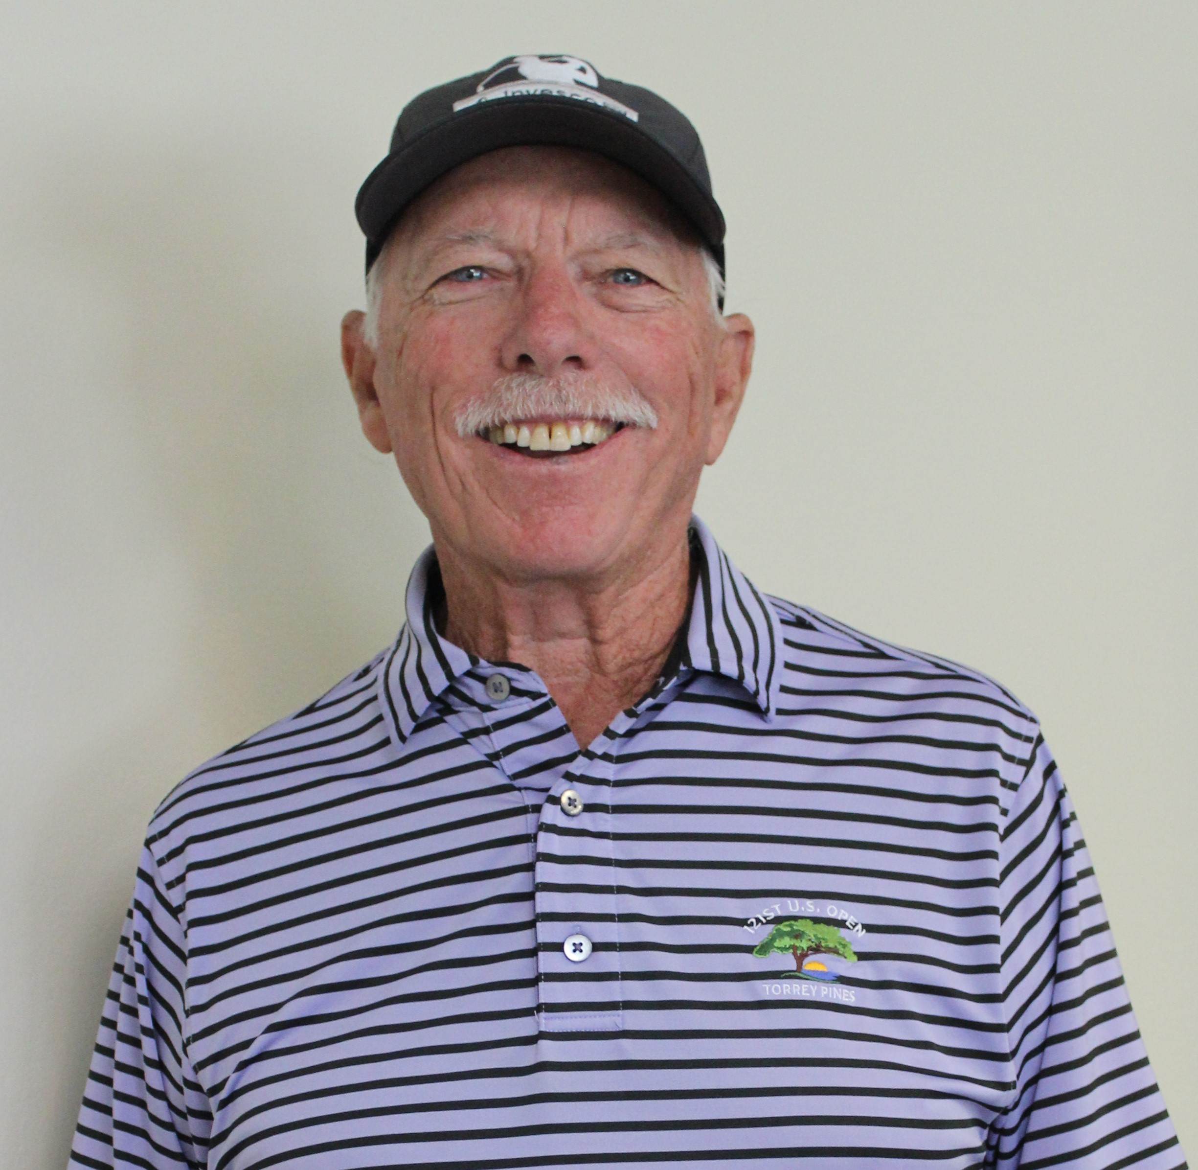

***Flt A LN- Peter Hong 76/net70***

***Flt B LN- Bruce Yochim net 69***

***Flt C LN- Dan Sniegowski net 74***

***Flt A Skins- Hong (2); Tash, Seaberg, Kim, and Jenkins (one each)***

***Flt B Skins- Yochim (2); Burhans, Gouzy, Cho, and Hamilton (one each)***

***Flt C Skins- Sniegowski (3; McCormick and Oatway (one each)***

***CTP- Sy (2), Beckenstein (2); Nguyen, Shin, and Lee (one each)***

***Pool- Oatway and Beckenstein***

***Nov. 15 – Turkey Shoot and Annual Meeting Shotgun. Dick Bratkovich chaired this special tournament that is between members of the foursome. Low Net winners get $20; 2nd gets $15; 3rd gets $10; and last gets $5.***

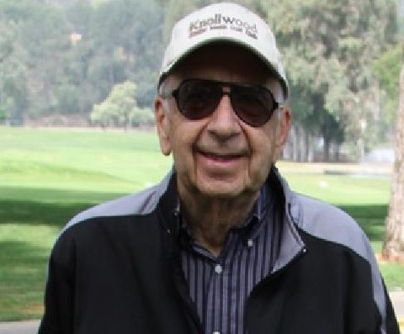

***Winners were: Bratkovich, Lebetsamer, Pearson, Sniegowski, Yochim, Lindeen, Jones, Scott, Hong, Jenkins, Kim, Manian, and Johnson.***

***Nov. 29 – Low Net, Low Gross, and Skins @ Knollwood. Gary Scott served as Chairman.***

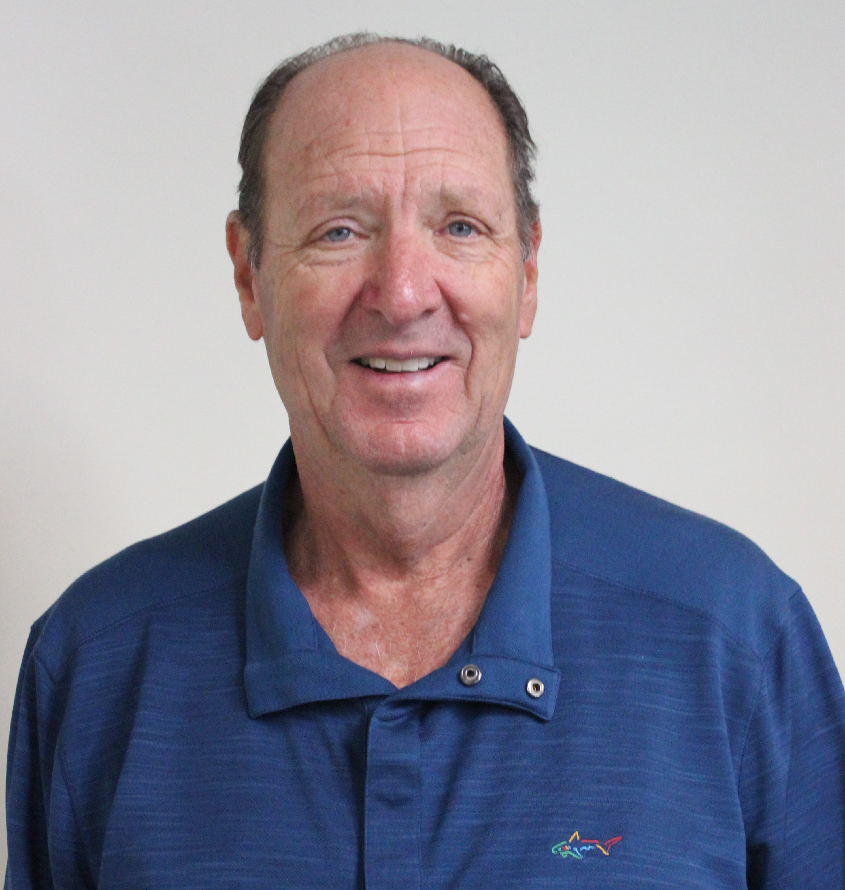

***Flt A LN- P. Hong 75/net70***

***Flt B LN- W. Jenkins 89/net72***

***Flt C LN- J. McCormick 95/net70***

***Flt A Skins- Hong (3); Beckenstein, S. Kim, Manjikian, C. Kim, and Dimacali (one each)***

***Flt B Skins- Hamilton (2); Riley, Savilla, Yochim, Jenkins, and Greer (one each)***

***Flt C Skins- Halani (3), McCormick (3), Goldstein (2); Bella, Clark, and Bratkovich (one each)***

***LG Flt A- Kang (75); LG Flt B- Riley (95); LG Flt C- Manian (112)***

***CTP- Scott, Beckenstein, Hamilton, Kang, Halani, and Hong (one each); Pool- Beckenstein & Hamilton***

***Dec. 6 – Low Net, Low Gross, and Skins @ Knollwood. Brian Mason was the Chairman for this event.***

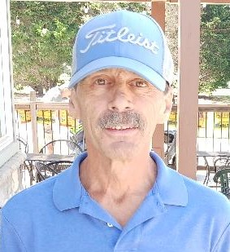

***Flt A LN- A. Manjikian 83/net69***

***Flt B LN- W. Jenkins 86/net69***

***Flt C LN- D. Bratkovich 113/net75***

***Flt A Skins- C. Kim (3); Pearson, Beckenstein, and Mason (one each)***

***Flt B Skins- Gouzy (2); S. Kim, Chapin, Jenkins, Hamilton, and Greer (one each)***

***Flt C Skins- Rozewicz (4), Halani (2); Clark, Bratkovich, Ensell, Sy, and Samosa (one each)***

***LG Flt A- Kang (81)***

***LG Flt B- Gouzy (97)***

***CTP- Kang (2); Dimacali, Manjikian, Schwartz, and Ensell (one each)***

***Pool- Kang and Beckenstein***

***Dec. 13 – Two-Man Partner Better Ball @ Knollwood. Bill Brocklebank served as Chairman.***

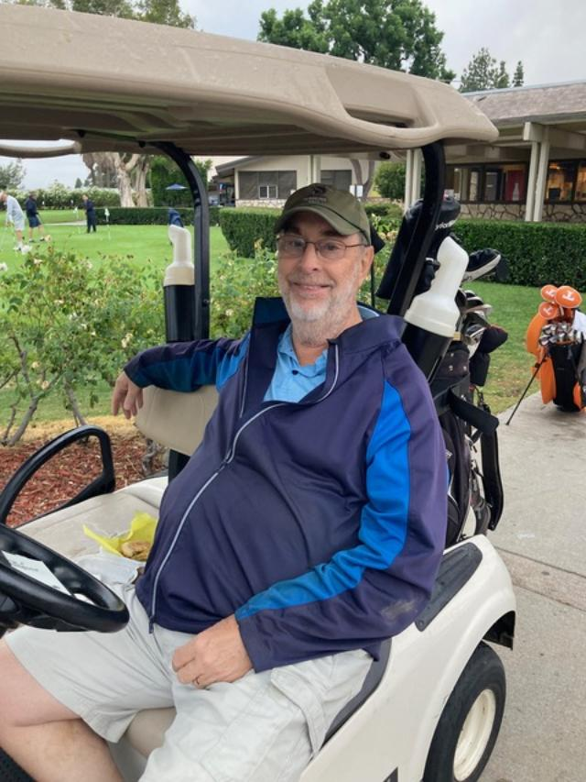

***Flt 1 – 1st: C. Inman and B. Yochim – Net 66 (tie breaker)***

***Flt 1 – 2nd; P. Hong and C. Kang – Net 66***

***Flt 1 – 3rd; KC Riley and G. Scott – Net 67 (tie breaker)***

***Flt 2 – 1st; R. Dimacali and H. Savilla – Net 64***

***Flt 2 – 2nd; M. McGann and R. Lindeen – Net 65 (tie breaker)***

***Flt 2 – 3rd; W. Jenkins and P. Hamilton – Net 65***

***Flt 3 – 1st; D. Bratkovich and N. Clark – Net 64 (tie breaker)***

***Flt 3 – 2nd; J. Goldstein and J. Bella – Net 64***

***Flt 3 – 3rd; R. Rozewicz and H. Samosa – Net 65***

***CTP- Sniegowski, Yochim, Savilla, Chang, Ensell, S. Kim, Hamilton, and Lehr (one each)***

***Pool- Savilla and Scott***

***KSMGC MINUTES: DECEMBER 4, 2023***

BOARD MEMBER ATTENDEES: CLARK, BRATKOVICH, BELLA, OATWAY, LINDEEN, NGUYEN, SEABERG, HALANI, H. HORNBECK, GREER, RIEKEN & PEARSON

Dick Bratkovich: The November 1, 2023 and November 15, 2023 Minutes were submitted and approved by the Board.

Norris Clark: A meeting will be held with KCC management to reserve the 2024 home tournament dates.

Gordon Seaberg: There is $13,654.62 in the treasury. After potential deposits and payouts, the book balance is $8, 967.87. The year-end projected book balance is $8,967.87.

John Nguyen: The following away tournaments have been booked with the noted golf courses: Jan. 17 – Santa Anita, Feb. 21 – Olivas Links, Mar. 20 – Sand Canyon, Apr. 24 – River Ridge, May 15 – Los Robles, June 19 Sterling Hills.

Norris Clark: Steve Skinner will become a Scoring Chairman.

Mike Rieken: Membership is 116.

Tom Oatway: The next Newsletter will be issued at the end of December.

Jim Greer: We are waiting for DeBell to schedule the 2024 Interclub matches. We need to decide the location of the 2024 Central Coast outing – Solvang, Pismo Beach or ?

UNFINISHED BUSINESS:

* The website FAQs will have a more visible tab. We need to finish the update of the Handicap FAQ.

NEW BUSINESS:

* A discussion of on-line payment of tournament entries was tabled.
* A decision was made to have no play-off between Flight A and Flight B champions in the 2024 Match Play completion.
* The home tournament cancellation deadline for individual players will remain at Tuesday 9PM.
* We need a new Rules Chairman.
* Larry Tash will be asked if he will be our SCGA representative.
* A new KSMGC banner will be put up in April after wind season.
* We need to understand the requirements for certification of our Handicap Chairman and the SCGA 2024 certification of our Club.

Next meeting: January 8, 2024 at 1PM

Richard Bratkovich, Secretary

ON THE FRINGE…

*Subject: Understanding Engineers*

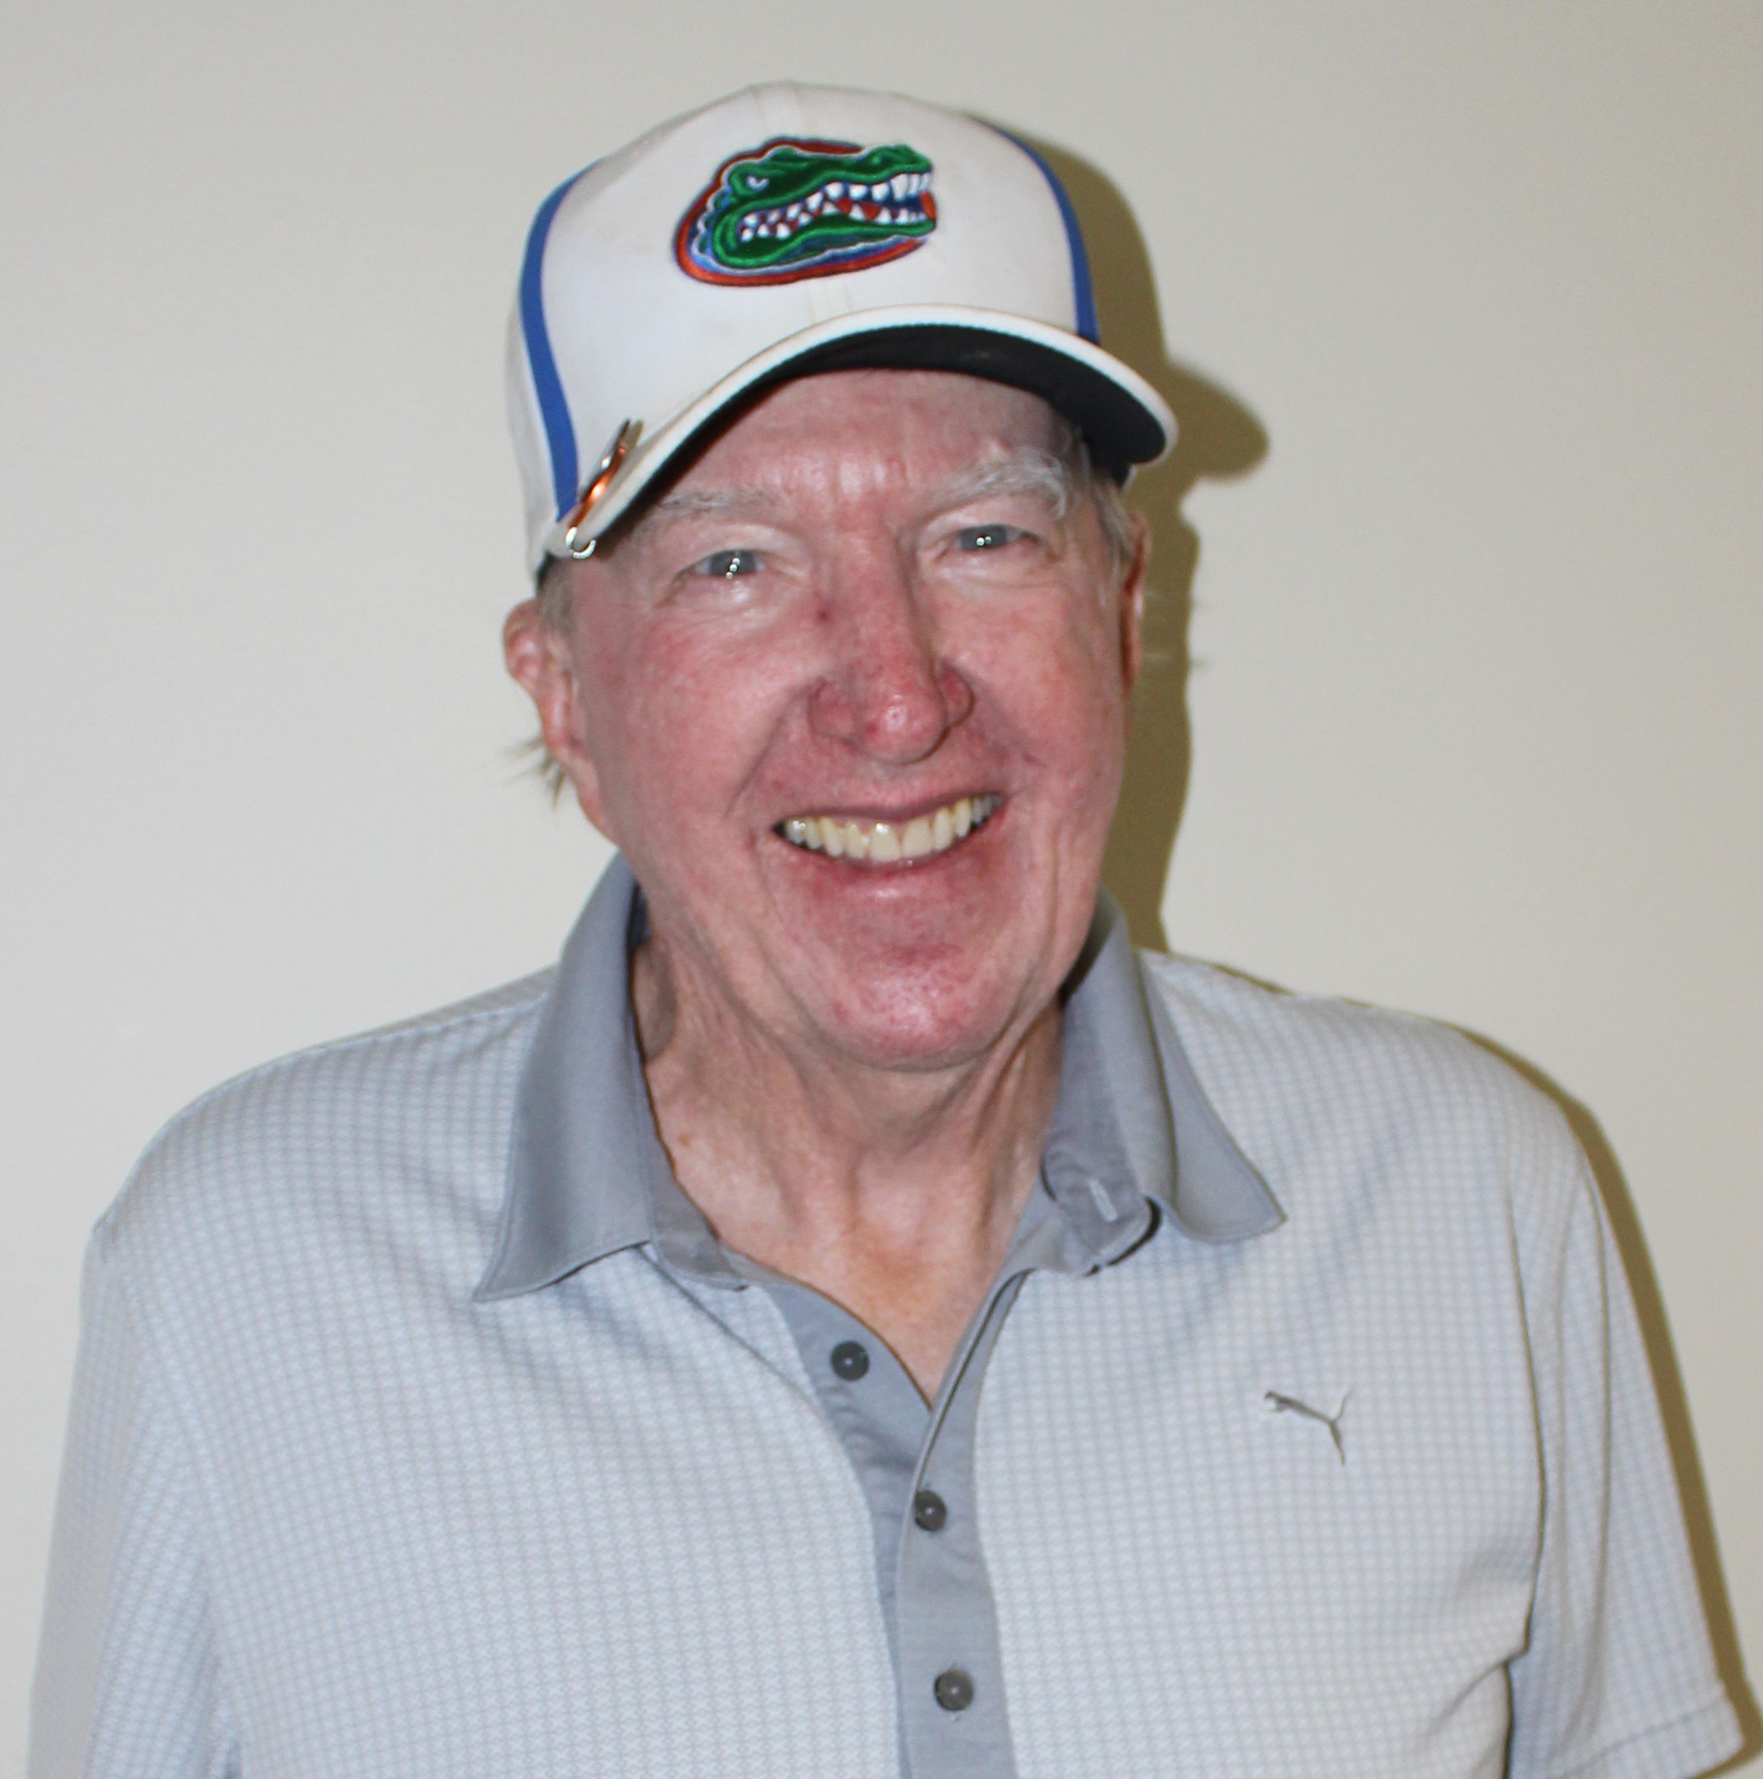

Two engineers were standing at the base of a flagpole, looking at its top. A woman walked by and asked what they were doing. “We’re Supposed to find the height of this flagpole” said one man, “but we don’t have a ladder”. The woman took a wrench from her purse, loosened a couple of bolts, and laid the flagpole down on the ground. Then she took a tape measure from her pocketbook, took a measurement, and announced “Twenty-one feet, six inches”, and walked away. One engineer shook his head and laughed, “A lot of good that does us. We ask for the height and she gives us the length”!!!

Both engineers have since quit their jobs and are currently serving in the United States Congress and on the board of KSMGC.