The KSMGC News **May-June 2024**

Knollwood Senior Men’s

EVENTS CALENDAR

***Tues., July 2 Knollwood Board/Membership Mtg. at 10:00am***

***Wed, July 3 Knollwood LN/LG/Skins Charlie Inman***

***Wed., July 10 Knollwood LN/LG/Skins Peter Hong***

***Wed, July 17 Knollwood LN/LG/Skins Bruce Yochim***

***Wed, July 24 Olivas Links LN/LG/Skins Steve Burhans***

***Wed, July 31 Knollwood 2-Man PBB Gary Scott***

***Tues., Aug 6 Knollwood Board/Membership Mtg at 10 am***

***Wed, Aug 7 Knollwood LN/LG/Skins Mike Gallego***

***Wed, Aug 14 Knollwood LN/LG/Skins John Nguyen***

***Wed, Aug 21 River Ridge Lakes LN/LG/Skins John Nguyen***

***Wed, Aug 28 Knollwood Skins Game Dick Bratkovich***

***Tues, Sept 3 Knollwood Board/Membership Mtg at 10 am***

***Wed, Sept 4 Knollwood LN/LG/Skins JN Rivera***

***Wed, Sept 11 Knollwood LN/LG/Skins Tom Oatway***

***Wed, Sept 16-17 Solvang Get-Away LN/LG/Skins Jim Greer***

***Wed, Sept 25 Knollwood 2-Man Scramble Chris Cho***

***SOLVANG GETAWAY NEWS-*** As of today, July 2, 2024, due to the excellent response we received from our members, we have reached the total allotment provided KSMGC to play Alisal's Private Ranch Golf Course on Tuesday, Sept. 17, 2024.  Accordingly, we are accepting entries toward a "wait list" for members, and entries will be added in the order their application is received.

Please note that there are still openings to play at The Mission Golf Club on Monday, Sept. 16th and to participate in our Annual get together on Monday afternoon at the Solvang Brewing Co. Note there are numerous other activities to enjoy while visiting Solvang in case no slots for golf at Alisal's Ranch Course become available, but openings may still occur as we approach our get-a-way dates.

If interested, continue sending your entry and fees to Jim Greer to be included to our wait list.  We will keep you posted if changes to the current status occurs.

Thanks, Jim Greer, [jimmyg0909@yahoo.com](mailto:jimmyg0909@yahoo.com)

Golf Club – Est. 1983

[www.ksmgcgolf.com](http://www.ksmgcgolf.com)

[ksmgcgolf@gmail.com](mailto:ksmgcgolf@gmail.com)

Board of Directors

President (2024)

***Norris Clark***

***818-472-9382***

1st VP - Tournament Chm.

***Andy Halani (2024)***

***818-800-2632***

2nd VP - Handicap Chm.

***Hewitt Hornbeck (2024)***

***818-368-3964***

Secretary- (2024)

***Dick Bratkovich***

***818-886-4514***

Treasurer – (2024)

***Gordon Seaberg***

***323-822-1971***

Away Tournament Chm. (2024)

***John Nyugen 818-261-4982***

Rules Chairman ***(2024)***

***Peter Hong 818-970-5651***

Membership Chairman

***Mike Rieken***

***818-399-9510***

Webmaster (2024)

***Bill Brocklebank***

***805-509-2222***

Scoring Chairmen:

***Mike McGann***

***818-317-9042***

***Steve Burhans***

***661-877-2608***

***Neil Beckenstein***

***818-360-4858***

Scoring Chairman

***Steve Skinner***

***818-585-6853***

Newsletter Chairman

***Tom Oatway***

***661-263-9778***

Photographer

***(Needed)***

Interclub Chairman

***Jim Greer***

***818-999-1220***

Past President

***Allison Fields***

***Page 2***

***RULES REMINDERS- Peter Hong.***

***Please continue to adhere to a fast pace of play. With the hot summer months ahead of us, it will be increasingly important to get off the course as quickly as possible. Our first tee time has been moved up 30 minutes to 7:00AM. This will help.***

***Please play ready golf, do your scoring at the following tee box, and turn in your scorecards promptly to the Chairman upon finishing your round. All 4 players must attest that the card is accurate. If your tee group falls behind, you can split up into twosomes to catch up to the group ahead. Alternatively, you can let a faster following group play through. Remember: a two-stroke penalty can be assessed to your entire foursome if you turn your card in 20 or more minutes behind the group ahead.***

***TOURNAMENT ENTRY FORMS- The entry forms for July and August 2024 are attached below, and are also available on the KSMGC website. Please note that your entry for a home tournament is due to the chairman 9 days prior to the event, and entry forms for away tournaments are due 14 days prior.***





***OPEN POSITIONS ON KSMGC BOARD OF DIRECTORS: The open position of Photographer is still open. If you have a digital camera or a cell phone and would be willing to take a few photos of members and special events such as the Annual Meeting, please contact Norris Clark.***

***HOLE-IN-ONE Challenge for 2024: Steve Burhans recorded an ace at Sterling Hills. Congrats, Steve. He will share the Hole-in-One pool with anyone who also records an ace in a KSMGC tournament prior to the end of the year. If not, Steve will collect the entire pool. We’d better up our games.***

***SINGLES MATCH PLAY TOURNAMENT- The final matches have been set in Flt A and B. Chong Kang and Jesus Cruz will square off in Flt A. KC Riley and Chris Cho will compete for the Flt B crown. Jim McCormick ran this tournament and did a great job. Results of the final matches will be posted on the website.***



***Remembering Bruce Welch***

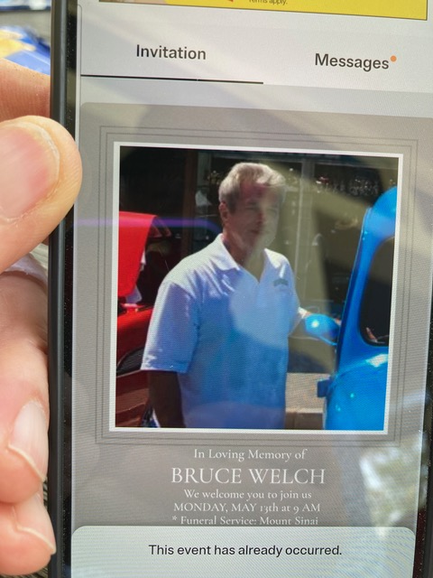

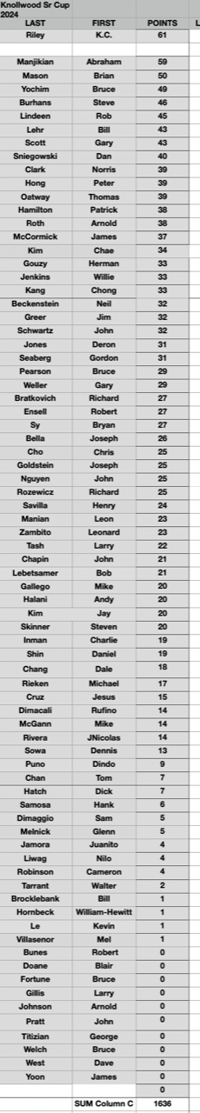

***Senior Cup- The standings as of June 28, 2024 are as shown:***

***TOURNAMENT HIGHLIGHS-***

**May 1*- Low Net, Low Gross, and Skins @ Knollwood. Bill Brocklebank chaired this tournament. `***

***Flt A LN- Abe Manjikian- 80/net67***

***Flt B LN- Chris Cho- 90/net68***

***Flt C LN-*** ***Lindeen- 99/net71***

***Flt A Skins- Jones (2); Mason, C. Kim, Seaberg (one each)***

***Flt B Skins- Lehr, Greer, Riley, Yochim, Cho, Savilla (one each)***

***Flt C Skins- Oatway (2); Ensell, Goldstein, Clark, Bella (one each)***

***Flt A LG- Kang (75); Flt B LG- Jenkins (88)***

***CTP- Kang (2); Zambito, Sy, Inman, Savilla (one each)***

***Pool- Zambito & Mason***

**May 8 *– Low Net, Low Gross, and Skins @ Knollwood. Herman Gouzy chaired this tournament.***

***Flt A LN- Chae Kim- 80/net67***

***Flt B LN- Pat Hamilton- 96/net70***

***Flt C LN- Rob Lindeen- 95/net68***

***Flt A Skins- Mason (2), Manjikian (2); Gouzy, C. Kim, Jenkins (one each)***

***Flt B Skins- Lehr (2), Riley (2)***

***Flt C Skins- Goldstein (2); Ensell, Lindeen, Clark, Schwartz, Bratkovich, Sy, Jamara (one each)***

***CTP- Savilla (2); Manjikian, JN Rivera, Tash, Mason (one each)***

***Pool- Burhans & Savilla***

**May 15 *– Low Net, Low Gross, and Skins @ Los Robles. Peter Hong served as Chairman.***

***Flt A LN- Chae Kim- 79/net65***

***Flt B LN- KC Riley- 90/net71***

***Flt C LN- Rob Lindeen- 96/net73***

***Flt A Skins- Hong (2); Mason, Seaberg, Pearson, Robinson (one each)***

***Flt B Skins- Riley, McGann, Gouzy (one each)***

***Flt C Skins- Lindeen (2); D. Shin, Ensell, Roth, Bratkovich, Goldstein (one each)***

***LG Flt A- Kang (75); LG Flt B- Riley (90); LG Flt C- Hamilton (102)***

***CTP- Rieken (2); Mason, Manjikian, Lindeen (one each)***

***Pool- None for away tournaments***

***May 22- Two-Man Scramble @ Knollwood. This tournament was chaired by Mike Gallego with help from Rob Lindeen.***

***Flt A LN- Chae Kim & Leonard Zambito- 72/net62***

***Flt B LN- Larry Tash & Deron Jones- 73/net59***

***Flt C LN- Tom Oatway & John Schwartz- 87/net64***

***CTP- Lindeen, Hong, Rozewicz, Seaberg, Kang, Zambito (one each)***

***Pool- Rozewicz & Cruz***

***Results (continued)***

***May 29- Low Net, Low Gross, and Skins @ Knollwood. Deron Jones chaired this tournament.***

***Flt A LN- Hong- 75/net70***

***Flt B LN- Hamilton- 96/net71***

***Flt C LN- Rob Lebetsamer- 99/net70***

***Flt A Skins- Pearson, Hong, Zambito, Kim, DiMaggio (one each)***

***Flt B Skins- Riley (2); Seaberg, Burhans, Cho, Hamilton (one each)***

***Flt C Skins- Lebetsamer (3); Roth (2); Lindeen, Ensell, Sy, Goldstein, Bratkovich (one each)***

***LG Flt A- Hong (75); LG Flt B- Jenkins (88)***

***CTP- Lebetsamer; Kang, Hamilton, Pearson, Cho (one each)***

***Pool- Beckenstein & McCormick***

***June 5- Low Net, Low Gross, and Skins @ Knollwood. Tom Oatway served as Chairman.***

***Flt A LN- Zambito-83/net69***

***Flt B LN- JN Rivera- 89/net 69***

***Flt C LN- Arnold Roth- 109/net74***

***Skins Flt A- Scott (2); Zambito, Seaberg (1 each***

***Skins Flt B- Yochim (2); Riley, JN Rivera (1 each)***

***Skins Flt C- Roth (3); Schwartz (2)***

***CTP- Manjikian (2); Hong, Sniegowski, Kang, JN Rivera, Scott (1 each)***

***Pool- Jenkins & Clark***

***June 12- Low Net, Low Gross, and Skins @ Knollwood. Andy Halani served as chairman.***

***Flt A LN- Abe Manjikian- 83/net71***

***Flt B LN- JN Rivera- 92/net72***

***Flt C LN- Rich Rozewicz- 102/net***

***Flt A Skins- Jones (3); Kim, Pearson, Hong (one each)***

***Flt B Skins- Hamilton (2); Tash, Greer, Gouzy, Rivera, Cho, Chang (one each)***

***Flt C Skins- Lindeen (3); Shin, Roth (one each)***

***Flt A LG- Hong (77); Flt B LG- Riley (93)***

***CTP- Lindeen, Pearson, Cho, Scott, Greer, Hong (one each)***

***Pool- Greer & Scott***

***June 19- Low Net, Low Gross, and Skins @ Sterling Hills. Steve Burhans served as chairman and he also had a Hole-in-One. Congrats, Steve. Note: Our members enjoyed this course and the free meal provided.***

***Flt A LN- John Nguyen- 76/net68***

***Flt B LN- Steve Burhans- 80/net66***

***Flt C LN- Mike Gallego- 88/net66***

***Flt A Skins- Beckenstein (3); Weller (2); DiMaggio (one)***

***Flt B Skins- Burhans (2); Jones, Seaberg, Gouzy, Riley (one each)***

***Flt C Skins- Hamilton (3); Goldstein (2); McCormick, Roth, Rieken, Bella (one each)***

***Flt A LG- Nguyen (76); Flt B LG- Burhans (80); Flt C LG- Hamilton (91)***

***CTP- Burhans (2); Inman, Nguyen (one each)***

***Pool- No pool for away events***

***Results (continued):***

***June 19- 4-Man Shamble @ Knollwood. KC Riley served as chairman.***

***1st LN- Scott, Lehr, Rieken, Roth- Net 60***

***2nd LN- Pearson, Riley, Manian, Halani- Net 63***

***3rd LN- Bratkovich, Greer, Kang, Tarrant- Net 64***

***CTP- Seaberg, Sy, Yochim, Schwartz, Manjikian, Mason, Halani (one each)***

***Pool- Greer & Halani***

***KSMGC MINUTES: June 2024***

Other Board Meeting Minutes are available on the KSMGC website.

KSMGC MINUTES: JULY 2, 2024

BOARD MEMBER ATTENDEES: CLARK, BRATKOVICH, LINDEEN, HORNBECK, SEABERG, RIEKEN, HALANI, BURHANS, OATWAY, BELLA, GREER & NGUYEN.

Dick Bratkovich: The June 4, 2024 Minutes were submitted and approved by the Board.

Gordon Seaberg: There is $21,338.68 in the treasury. After potential deposits and payouts, the year-end predicted book balance is $6,768.68

Andy Halani: JN Rivera will chair the September 4 event at Knollwood. Tom Oatway took the September 11 tournament. We now have all chairman positions filled.

Hewitt Hornbeck passed out the latest handicap report, which also will be posted on the KSMGC Bulletin Board.

Mike Rieken: Membership is 122. We will see if something can be done with the SCGA to increase our Associate membership. Tom Oatway asked Mike to give him a list of members who joined KSMGC in 2024.

Tom Oatway: The next Newsletter will be issued (posted on the web site and emailed) later this week.

Rules Update: Peter Hong will be asked to define the area on the right side of the Knollwood hole #15 fairway bunker that will be re-designating “ground under repair” in KSMGC local rules.

Norris Clark for Bill Brocklebank: The website is being kept current.

Jim Greer:

* Interclub: The trophy plate which shows KSMGC as the 2024 champion has been ordered.
* Solvang September Getaway: The second round of play at Alisal is now full with 36 players. Future entrants will be placed on a wait list on a “first come, first served” basis. There is no limit on entrants in the first round. An email blast will be sent to the membership on this subject.

Norris Clark for Jim McCormick: The A&B champion Match Play matches will be completed in July.

Joe Bella: The Senior cup standings are complete through June and will be issued.

UNFINISHED BUSINESS:

* Norris Clark and Dick Bratkovich met with Brian Carrico and verified that Knollwood will still give a free play to KSMGC members who bring in a new member and to 12 Senior Cup winners. Carrico stated that the free hamburger lunches were cancelled by American Golf in New York.

NEW BUSINESS:

* Various methods of 4 man scramble pairings and handicapping were discussed. Joe Bella will send KSMGC historical information on this subject to the Board.
* Knollwood has presented three buffet menu options for the annual meeting lunch to be held after the Turkey Shoot tournament.
* Norris Clark and Dick Bratkovich will draft words for the KSMGC By-Laws regarding the duties and membership of a Competitions Committee.
* Having a “Skins Game” on August 28 was verified.

Next meeting: Tuesday August 6, 2014, 10AM

Richard Bratkovich, Secretary

***ON THE FRINGE…***

***